**UNIT - 5**

**ODBC vs JDBC**

| **Feature** | **ODBC** | **JDBC** |
| --- | --- | --- |
| 1. Stands for | **Open Database Connectivity** (ODBC) | **Java Database Connectivity** (JDBC) |
| 1. Introduced by | **Microsoft** in **1992** | **Sun Microsystems** in **1997** |
| 1. Language Compatibility | Supports **multiple languages like C, C++, Java**, etc. | Specifically designed for **Java** |
| 1. Platform Compatibility | Typically used on **Windows platform** | **Platform-independent**, works on any platform |
| 1. Driver Implementation | Usually **developed in native languages like C and C++** | Implemented in **Java** |
| 1. Programming Paradigm | **Procedural Programming** | **Object-oriented Programming** |
| 1. Connection Setup | Uses **Data Source Names** (**DSN**) or **connection strings** | Uses **JDBC URL, username, and password** |
| 1. Error Handling | Error handling done using functions like **SQLGetDiagRec** | **Standardized exceptions** for error handling |
| 1. Driver Management | **Requires a separate driver manager** | **Included in Java runtime environment** |
| 1. Data Fetching | Supports **forward-only cursors** for data retrieval | Supports **both forward-only and scrollable** result sets |
| 1. Stored Procedure Support | **Does not directly support stored procedures**, implementation varies across databases | **Provides a Callable Statement interface for executing stored procedures**, ensuring a standardized approach |
| 1. Performance | **For Java applications** it is not recommended to use ODBC because performance will be down due to internal conversion and applications will become platform-dependent. | **For Java applications** it is highly recommended to use JDBC because there are no performance & platform dependent problems. |

**RDBMS vs OODBMS**

| **BASIS** | **RDBMS** | **OODBMS** |
| --- | --- | --- |
| Long Form | Stands for Relational Database Management System. | Stands for Object Oriented Database Management System. |
| Way of storing data | Stores data in **Entities**, defined as **tables** | Stores data as **Objects**. |
| Data Complexity | Handles comparatively **simpler data**. | Handles **larger and complex data** than RDBMS. |
| Grouping | Entity type refers to the **collection of entity that share a common definition**. | Class describes a **group of objects that have common relationships**, **behaviors**, and also have **similar properties**. |
| Data Handling | RDBMS stores **only data**. | Stores **data as well as methods to use it**. |
| Main Objective | **Data Independence** from application program. | **Data Encapsulation** |
| Key | A **Primary key** distinctively identifies an object in a table. | An **object identifier** (OID) is an unambiguous, long-term name for any type of object or entity. |
| Data Retrieval | **SQL** (Structured Query Language) | **OQL** (Object Query Language ) |
| Scalability | RDBMS has **Limited scalability** **due to rigid schema** | OODBMS has **Higher scalability** **due to flexible schema** |
| Concurrency Control | RDBMS has **Fine-grained locking** | OODBMS has **Optimistic concurrency control** |
| Data Relationships | Relationships **between tables using foreign keys** | Relationships **between objects using references or associations** |
| Performance | RDBMS is **Efficient for complex queries involving multiple tables** | OODBMS is **Faster for complex object-oriented queries** |
| Flexibility | RDBMS has **Limited flexibility due to fixed schema** | OODBMS has **higher flexibility due to object-oriented nature** |
| Type of Model | Follow **Relational Model** | Follow **Object-Oriented Model** |
| Data Persistence | In RDBMS Data is **stored in** **tables on disk** | In OODBMS Data is **stored in** **objects in memory or on disk** |
| Cost Involved | Comparatively **cheaper** than OODBMS | Comparatively **costlier** than RDBMS because it requires specialized software and hardware |
| Examples | MySQL, Oracle, SQL Server | db4o, Versant, Objectivity/DB |

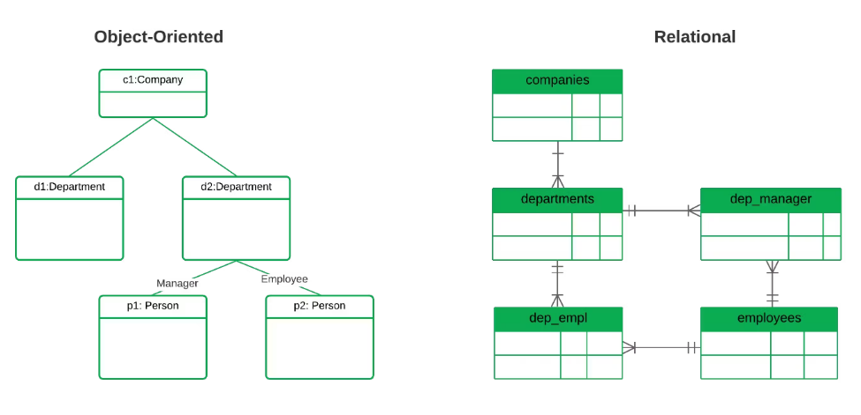

**Object Oriented Database Model (OODB)**

The Object-Oriented Database Model (OODB) is a type of database model that represents data as objects, much like in object-oriented programming languages. In an OODB, data is organized in the form of objects, which encapsulate both data (attributes or fields) and behavior (methods or functions). These objects are stored in the database and can be manipulated using object-oriented principles such as inheritance, encapsulation, and polymorphism.

In Object Oriented Data Model, data and their relationships are contained in a single structure which is referred as object in this data model. In this, real world problems are represented as objects with different attributes. All objects have multiple relationships between them. Basically, it is combination of Object Oriented programming and Relational Database Model as it is clear from the following figure :

**Object Oriented Data Model** = Combination of Object Oriented Programming + Relational database model

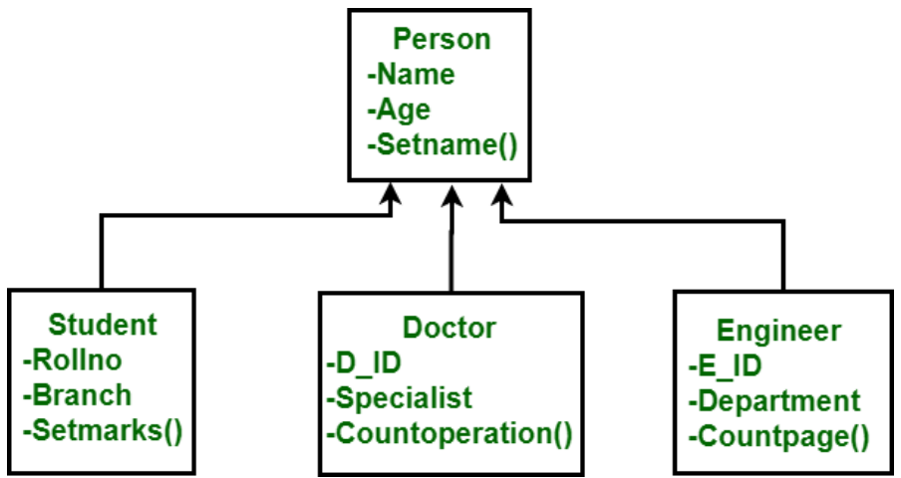

Key features of the object-oriented database model include:

1. **Objects**: Data is represented as objects, which are instances of classes defined in the database schema. Each object has attributes (data fields) and methods (functions) that operate on the object's data.
2. **Classes**: Objects are organized into classes, which define the structure and behavior of objects of the same type. Classes may include attributes to represent data and methods to perform operations on the data.
3. **Inheritance**: Classes can inherit attributes and methods from other classes, allowing for code reuse and hierarchical relationships between classes. This enables the creation of class hierarchies where more specialized classes inherit from more general ones.
4. **Encapsulation**: Objects encapsulate both data and behavior, ensuring that data is accessed and modified through well-defined methods. This promotes data integrity and modularity in the database schema.
5. **Polymorphism**: Objects can respond to the same message (method call) in different ways based on their specific implementation. This allows for dynamic behavior and flexibility in object interactions.
6. **Abstraction**: OODB provides abstraction mechanisms to hide the implementation details of data storage and retrieval, allowing developers to focus on the conceptual model of the application. Abstraction enables a clear separation between the application logic and the underlying database structure, making the system easier to understand, maintain, and evolve over time.
7. **Complex Data Types**: OODB supports complex data types such as arrays, sets, lists, and user-defined types, allowing for the representation of diverse data structures.
8. **Persistence**: Objects in an OODB can be persisted to disk and retrieved from the database over time, ensuring that data is stored permanently and can be accessed even after the application terminates.
9. **Query Language**: OODB typically provides a query language that supports object-oriented concepts such as inheritance, polymorphism, and navigation of object graphs. This allows for expressive and efficient querying of complex data structures.

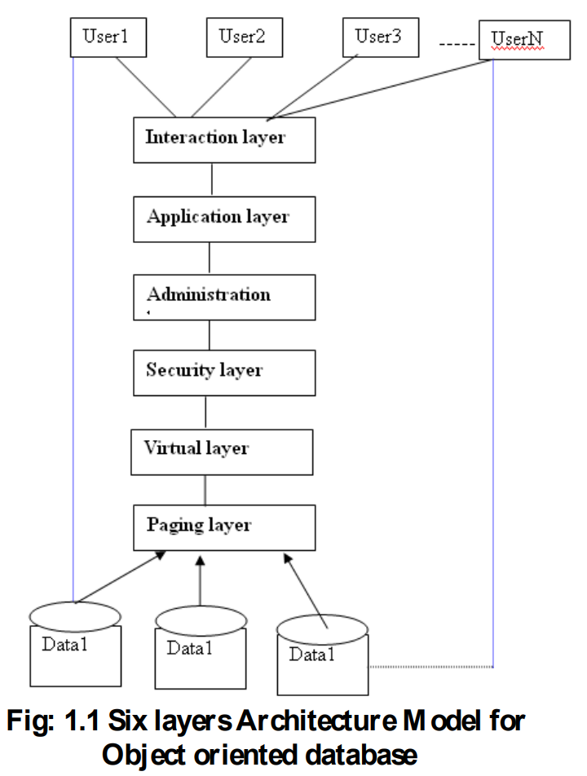

**Object Oriented Database Management System (OODBMS)**

### The **ODBMS** which is an abbreviation for**object-oriented database management system** is the **data model in which data is stored in form of objects, which are instances of classes**. These **classes and objects together make an object-oriented data model**.  ***Components of Object-Oriented Data Model:*** The OODBMS is based on three major components, namely: Object structure, Object classes, and Object identity. These are explained below.  **1. Object Structure:** The structure of an object refers to the properties that an object is made up of. These properties of an object are referred to as an attribute. Thus, an object is a real-world entity with certain attributes that makes up the object structure. Also, an object encapsulates the data code into a single unit which in turn provides data abstraction by hiding the implementation details from the user.  The object structure is further composed of three types of components: Messages, Methods, and Variables. These are explained below.

1. **Messages –**   
   A message provides an interface or acts as a communication medium between an object and the outside world. A message can be of two types:
   1. **Read-only message:** If the invoked method does not change the value of a variable, then the invoking message is said to be a read-only message.
   2. **Update message:** If the invoked method changes the value of a variable, then the invoking message is said to be an update message.
2. **Methods –**   
   When a message is passed then the body of code that is executed is known as a method. Whenever a method is executed, it returns a value as output. A method can be of two types:
   1. **Read-only method:** When the value of a variable is not affected by a method, then it is known as the read-only method.
   2. **Update-method:** When the value of a variable change by a method, then it is known as an update method.
3. **Variables –**   
   It stores the data of an object. The data stored in the variables makes the object distinguishable from one another.

**2. Object Classes:**   
An object which is a real-world entity is an instance of a class. Hence first we need to define a class and then the objects are made which differ in the values they store but share the same class definition. The objects in turn correspond to various messages and variables stored in them.

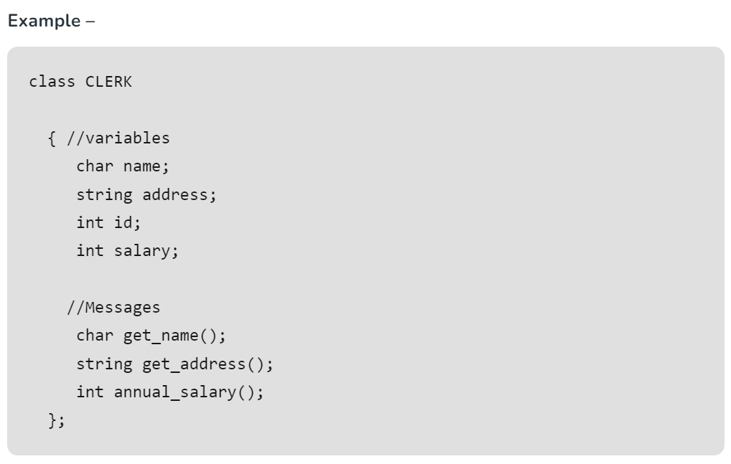

**3. Object Identity:**

Object Identity refers to the unique identifier assigned to each object stored in the database. Object identity distinguishes one object from another, allowing the database system to uniquely identify and access individual objects.

In OODB systems, object identity is often represented by a unique identifier, such as an object identifier (OID) or a universally unique identifier (UUID). These identifiers are assigned to objects when they are created and remain unchanged for the lifetime of the object.

Overall, object identity is a fundamental concept in OODB systems, enabling the unique identification and manipulation of objects within the database. It plays a crucial role in maintaining data integrity, supporting object relationships, and facilitating object-oriented programming paradigms in database applications.

### ***Features of ODBMS:***

**Object-oriented data model:**ODBMS uses an object-oriented data model to store and manage data. This allows developers to work with data in a more natural way, as objects are similar to the objects in the programming language they are using.

**Complex data types:** ODBMS supports complex data types such as arrays, lists, sets, and graphs, allowing developers to store and manage complex data structures in the database.

Automatic schema management: ODBMS automatically manages the schema of the database, as the schema is defined by the classes and objects in the application code. This eliminates the need for a separate schema definition language and simplifies the development process.

**High performance:** ODBMS can provide high performance, especially for applications that require complex data access patterns, as objects can be retrieved with a single query.

**Data integrity:**ODBMS provides strong data integrity, as the relationships between objects are maintained by the database. This ensures that data remains consistent and correct, even in complex applications.

**Concurrency control:** ODBMS provides concurrency control mechanisms that ensure that multiple users can access and modify the same data without conflicts.

**Scalability:**ODBMS can scale horizontally by adding more servers to the database cluster, allowing it to handle large volumes of data.

**Support for transactions:**ODBMS supports transactions, which ensure that multiple operations on the database are atomic and consistent.

### ***Advantages:***

**Supports Complex Data Structures:** ODBMS is designed to handle complex data structures, such as inheritance, polymorphism, and encapsulation. This makes it easier to work with complex data models in an object-oriented programming environment.

**Improved Performance:**ODBMS provides improved performance compared to traditional relational databases for complex data models. ODBMS can reduce the amount of mapping and translation required between the programming language and the database, which can improve performance.

**Reduced Development Time:**ODBMS can reduce development time since it eliminates the need to map objects to tables and allows developers to work directly with objects in the database.

**Supports Rich Data Types:**ODBMS supports rich data types, such as audio, video, images, and spatial data, which can be challenging to store and retrieve in traditional relational databases.

**Scalability:**ODBMS can scale horizontally and vertically, which means it can handle larger volumes of data and can support more users.

### ***Disadvantages:***

**Limited Adoption:**ODBMS is not as widely adopted as traditional relational databases, which means it may be more challenging to find developers with experience working with ODBMS.

**Lack of Standardization:**ODBMS lacks standardization, which means that different vendors may implement different features and functionality.

**Cost:**ODBMS can be more expensive than traditional relational databases since it requires specialized software and hardware.

**Integration with Other Systems**: ODBMS can be challenging to integrate with other systems, such as business intelligence tools and reporting software.

**Scalability Challenges:**ODBMS may face scalability challenges due to the complexity of the data models it supports, which can make it challenging to partition data across multiple nodes.

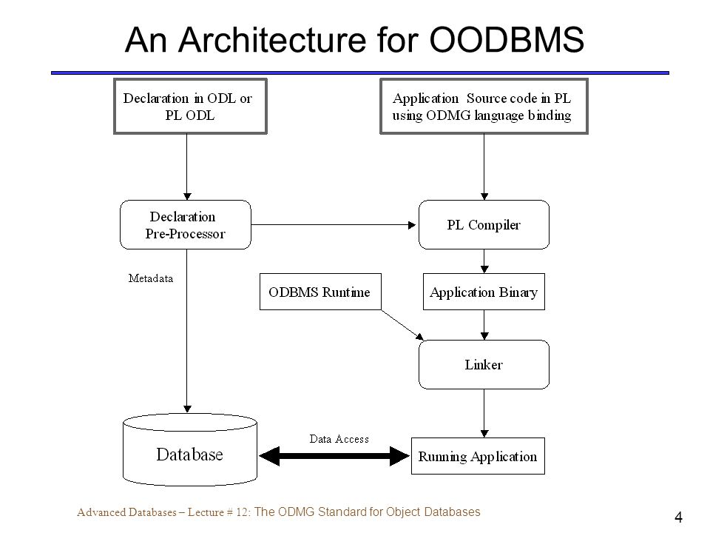

### ***ADO***

ADO (**ActiveX Data Objects**) is a **set of Microsoft technologies** used to access and manipulate data from various data sources, primarily in the context of relational database systems. However, ADO itself is **not typically used directly** in Object-Oriented Database Management Systems (OODBMS) environments.

In OODBMS environments, the **preferred method for accessing and manipulating data** is **through** the **OODBMS-specific APIs** or **query languages provided by the OODBMS vendor**. These APIs and query languages are **specifically designed to work with object-oriented data models and provide features such as object retrieval, manipulation, and navigation**.

That said, it's possible that in certain scenarios where OODBMS systems offer compatibility layers or bridges to relational databases, ADO could potentially be used to interact with the relational data stored within the OODBMS. However, this would typically involve some level of translation or mapping between the relational and object-oriented data models, and it may not fully leverage the capabilities of the OODBMS.

In summary, while ADO is a widely-used technology for accessing relational databases, it's not typically used directly in OODBMS environments. Instead, developers working with OODBMS would primarily interact with the database using the OODBMS-specific APIs, query languages, or object-oriented programming paradigms.

### ***DAO***

DAO (**Data Access Object**) is **a design pattern** **used to abstract the access to data sources, typically databases, in software applications**. It **provides an interface for accessing data and hides the implementation details of how data is retrieved and manipulated**. While DAO is often associated with relational databases, it can also be adapted for use in Object-Oriented Database Management Systems (OODBMS).

In the context of OODBMS, DAO can be **used to provide a consistent and unified interface for accessing and manipulating objects stored in the database**. The DAO pattern helps decouple the application code from the specifics of the database system, allowing for easier maintenance, testing, and flexibility in switching between different database implementations.

Here's how DAO can be implemented in an OODBMS environment:

1. **Interface Definition**: Define an interface that specifies the methods for accessing and manipulating objects in the database. This interface should include methods for CRUD operations (Create, Read, Update, Delete), as well as any other operations specific to the application's requirements.
2. **DAO Implementation**: Implement concrete DAO classes that provide the actual implementation of the methods defined in the interface. Each DAO class is responsible for interacting with the OODBMS to perform the desired operations on objects. These classes encapsulate the database access logic and hide the details of how objects are stored and retrieved.
3. **Object Mapping**: Implement object mapping logic to map objects between the application's domain model and the database schema. This may involve converting objects to and from the format expected by the OODBMS, handling object relationships, and managing object identity.
4. **Transaction Management**: Implement transaction management logic to ensure data consistency and integrity when performing multiple operations on objects. This may involve coordinating transactions, handling exceptions, and managing transaction boundaries.
5. **Error Handling and Logging**: Implement error handling and logging mechanisms to handle exceptions and log relevant information during data access operations. This helps diagnose and troubleshoot issues with data access and ensures robustness in the application.

By implementing the DAO pattern in an OODBMS environment, developers can achieve separation of concerns, maintainability, and flexibility in their applications' data access layer. DAO provides a clean and modular approach to accessing and manipulating objects in the database, making it easier to evolve and maintain the application over time.

### ***OLEDB***

OLE DB (**Object Linking and Embedding Database**) is **a Microsoft API** designed to provide a consistent interface for accessing various data sources including relational databases, spreadsheets, text files and more. While OLE DB is **primarily used with relational database management systems (RDBMS)**, it can **potentially be used in Object-Oriented Database Management Systems (OODBMS) environments with certain limitations and considerations**.

Here's how OLE DB could be used in an OODBMS environment:

1. **Compatibility Layers**: Some OODBMS vendors may provide compatibility layers or bridges that allow OLE DB to interact with the OODBMS. These layers typically translate OLE DB calls into the native API or query language of the OODBMS, enabling OLE DB clients to access and manipulate objects stored in the OODBMS.
2. **Custom Providers**: OODBMS vendors could develop custom OLE DB providers specifically designed to work with their database systems. These providers would implement the OLE DB interfaces and translate OLE DB calls into the appropriate operations for storing and retrieving objects in the OODBMS.
3. **Mapping Objects to Relational Data**: In scenarios where the OODBMS offers relational access to its data (e.g., through object-relational mapping or SQL interfaces), OLE DB could be used to access the relational data stored within the OODBMS. This approach may involve mapping objects to relational tables and using OLE DB to execute SQL queries against those tables.
4. **Performance and Limitations**: It's important to consider the performance implications and limitations of using OLE DB in an OODBMS environment. OLE DB is optimized for relational data access and may not fully leverage the capabilities of the OODBMS, such as object-oriented querying, navigation, and transaction management. Additionally, the translation between OLE DB and the native OODBMS API or query language could introduce overhead and complexity.
5. **Vendor Support**: Before using OLE DB with an OODBMS, it's crucial to verify whether the OODBMS vendor officially supports OLE DB integration and provides documentation, drivers, or tools for implementing OLE DB connectivity.

In summary, while OLE DB is primarily used with relational databases, it could potentially be used in OODBMS environments with the appropriate compatibility layers, custom providers, or mapping strategies. However, developers should carefully evaluate the performance, limitations, and vendor support when considering OLE DB integration with an OODBMS.